**Talha Khalid**

**F2021266625**

**V-04**

**Project Part-01**

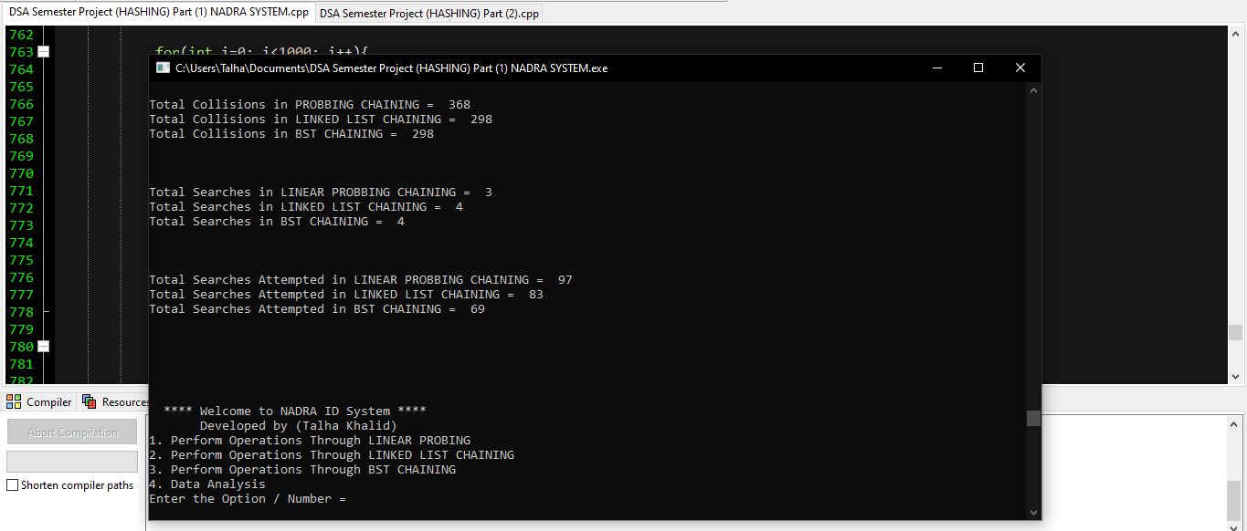

|  |  |
| --- | --- |
| **Technique** | **Total Collisions** |
| Linear Probing | 368 |
| Linked List Chaining | 298 |
| BST Chaining | 298 |

|  |  |  |
| --- | --- | --- |
| **Technique** | **Total Numbers Searched/Found** | **Attempts to Search** |
| Linear Probing | 3 | 97 |
| Linked List Chaining | 4 | 83 |
| BST Chaining | 4 | 69 |

**Which technique is best? State the reason.**

BST Chaining gives the best results (in terms of time complexity and searching) as compared to linear probing and linked list chaining. BST has a time complexity of O (log n) on the best and average cases for searching and inserting / deletion. But the linked list has time complexity in most cases O (n).